Table of Contents

Font- Times new roman.

Pages will have no borders. Text will be justified

Font Size

All heading in -16

Sub heading -14

Body- 12

Figures and tables will be numbered. The captions will be in bold italics font size 9. Will be placed below table/figure

Fig.chapter no.figno-name

-example 2nd diagram in chapter 3 will be named ***fig. 3.2 -system diagram***

***Table 2.4-list of components***

References will be IEEE format

IEEE standard

Book,

[1] J. F. Curtis, (Ed.), Processes and Disorders of Human Comm-unication. New York:

Harper and Row, 1978.

Journal Paper,

[2] J. Schroeterand M. M. Sondhi, “Techniques for estimating vocal-tract shapes from the

speech signal,”IEEE Trans. Speech Audio Process., vol. 2, no. 1, pp. 133–150, 1994.

Proceeding paper,

[3]J. M. Pardo, “Vocal tract shape analysis for children,” in Proc. IEEE Int. Conf.

Acoust., Speech, Signal Process., 1982, pp. 763–766.

|  |
| --- |
| **K. J. Somaiya Institute of Engineering and Information Technology**  **Ayurvihar, Sion, Mumbai- 400 022** |
| **Autonomous College Affiliated to University of Mumbai**    **A Project Report On** |
| **Title of Project** |
| SUBMITTED BY  **Nakshatra Joshi-**-(21253021)  **Heet Kalaria-**-(21253022)  **Vikram Kandoriya-**-(21253023) |
| Guide |
| **Prof. Vrinda Ullas** |
|  |
| **Department of Artificial Intelligence and Data Science** |
| 2021-22 |

**CERTIFICATE**



**K. J. SOMAIYA INSTITUTE OF ENGINEERING & INFORMATION TECHNOLOGY SION (E), MUMBAI 400022**

**UNIVERSITY OF MUMBAI**

This is to certify that the project titled **Password Generator** is completed under my supervision and guidance in partial fulfilment of the requirements of the course 1UAIPR31 Project Based Learning - Mini PR Lab-1, by the following students:

Nakshatra Joshi- (21253021)

Heet Kalaria- (21253022)

Vikram Kandoriya- (21253023)

The course is a part of semester III of the Department of Artificial Intelligence and Data Science during the academic year 2021-2022. The said work has been assessed and is found to be satisfactory.

(Internal guide name and sign.)

College seal

(External Examiner name and sign.)

1. INTRODUCTION
   1. AIM AND OBJECTIVES

The aim of our project is to generate Strong password which contains various combination of letters & symbols which make it difficult to crack the password. In this era we generates our profiles on various Websites for different purpose so it becomes necessary for us to set Each Password Strong & Different from other. In order to protect our own data. So to overcome this problem our Project come into place & provides the solution.

Objectives :

To Create Simple & user friendly platform for the project.

To solve the problem of setting different and strong password for each website you register on, which cant be done manually.

* 1. SOFTWARE REQUIRMENT

VS Code (IDE)

Java Development Kit (JDK)

MySQL Workbench (To Create & Store Database)

JDBC (To connect the database to our java project)

* 1. HARDWARE REQUIRMENT

1. SYSTEM DESIGN
   1. TABLE DESIGN
   2. DATAFLOW DIAGRAM
   3. ER DIAGRAM
   4. SYSTEM IMPLEMENTATION
      1. MODULE DESCRIPTION , SCREENSHOTS

The project implements a /*basic*/ GUI to display the (required) contents.

(As we start our project, the first window will appear which will ask for you to either login or Signup. If you are new user you have to Click on Signup then the signup window will appear in which you are supposed to fill all the required details then click on Submit to register successfully you will also receive a popup saying signup successful.

After that you have to click on login button then login window will appear fill the appropriate username & password & as you will click on Login it will check through the database that whether the details are correct or not. If its Correct then the final main dashboard will appear in which you can generate your Password )

As soon as we run the project there comes a pop out for us to register ourselves and we are supposed to fill out our name, surname, email, username and password. Moving ahead we are supposed to Login to access the password generator using the information we have filled during registration which is connected to the database. After entering the correct details we are now ready to use the password generating system. After logging in we get four choices i.e., to generate a Custom password, generate a random password, Save Password and Copy Password. When we click on Custom password the next thing we are supposed to do is to enter the sub fields according to the instructions given i.e., we are asked about the length of password(8-18 characters), Number of Uppercase and Lowercase Characters and Number of Special characters and if we exceed or decreed the number of characters it pops out an error. If we opt for random password the system will automatically generate a random password satisfying all the conditions and after getting the password on the screen we have two choices either we can save the password or copy the password and when we save the password it gets displayed in the text file which is created to store passwords.

1. CONCLUSION

The project is a /*simple*/ password generator, which we've built using Java. We have learnt a lot of new things (& implemented those)during the course of this project. We learnt how to work together as a team to ideate, and to translate our ideas to an actual (real time Database connected Working) project. We were able to experience how all the theory we had learnt during our java lectures was being applied to build something.This project has (Helped)allowed us to grow our skills as programmers.

We would like to thank our professor, Vrinda ma’am for constantly guiding us and helping us right from the ideation of the project to learning everything that was required to make the project, to its completion, and helping us understand how we can overcome any problems we faced at every stage.

1. REFERENCES

* Bro code Java Full Course : <https://youtu.be/xk4_1vDrzzo>

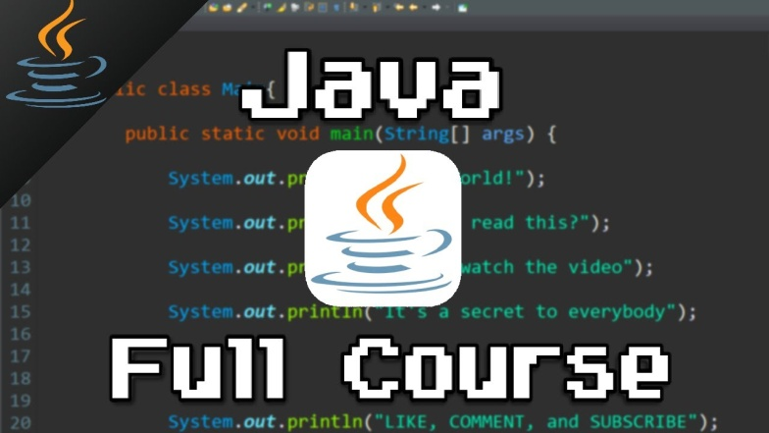

* Bro Code Java Swing Full Course: <https://youtu.be/Kmgo00avvEw>

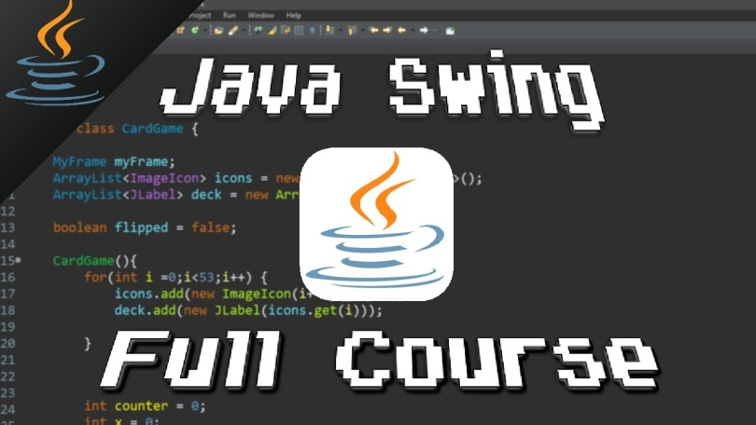

* JDBC : <https://youtube.com/playlist?list=PLEAQNNR8IlB4R7NfqBY1frapYo97L6fOQ>



